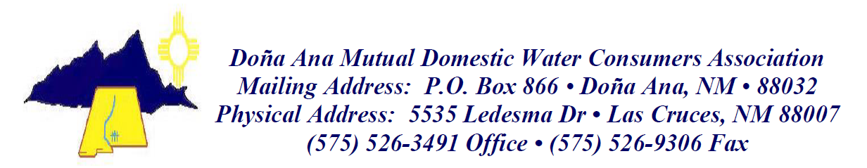

Notice of Addendum- 2:
There has been a correction to the RFP Evaluation Criteria Scoring Sheet for the following:
- RFP 2023-02; Engineering for Wastewater Services
-Page 12; #5- Work to be Done in New Mexico (See Attachment)
